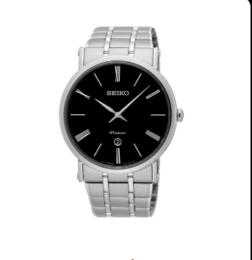

**Product Name:**

**Seiko Premier Men's Watch Black (SNP149P2)**

**Description:**

A sophisticated and elegant timepiece from Seiko’s Premier collection, designed for both style and functionality. It features a **black dial** with **Roman numeral markers**, a **stainless steel case**, and a **leather strap**, making it a refined choice for formal and casual wear.

**Specifications:**

* **Brand:** Seiko
* **Model Number:** SNP149P2
* **Band Material:** Leather
* **Band Color:** Black
* **Band Width:** 30mm
* **Case Material:** Stainless Steel
* **Case Diameter:** 43mm
* **Case Thickness:** 12mm
* **Clasp:** Buckle
* **Dial Color:** Black
* **Crystal Material:** Sapphire
* **Display Type:** Analog
* **Case Shape:** Round
* **Movement:** Quartz
* **Water Resistance Depth:** 50 meters

**Price:** $1,176